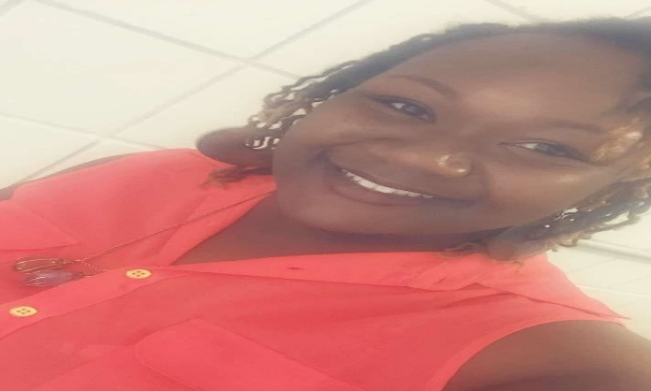

**Welcome Champions!!**

My name is Ms. Gibson and I am entering into my eighth year of teaching. I am originally from South Carolina where I taught 4 years (4th & 5th grade). This will be my 4th year as a Diamond Lakes Gem.

I graduated from South Carolina State University with a Bachelor degree in Elementary Education. (GO BULLDOGS!) I also graduated from South University with a Master degree in Leadership.

**I am excited to have you on my team this year!** I think it is important to work together as a classroom family. We will be spending a lot of time together, so it is essential to treat each other with respect, compassion, and kindness. I am here to help you in any way that I can!!

The **BEST** ways to contact me is via school phone, email, or the **Bloomz** app. If you have any questions, concerns, or want to inform me of anything you would like me to know about your student, please do not hesitate to contact me. Thank you so much and I am really looking forward to getting to know you and your student!

**School Phone:** 706-771-2881

**Email:** gibsocr@boe.richmond.k12.ga.us

**Bloomz Class Code:** 8NGRGS

Contact Me

My favorites

**Food**: Seafood (Crab, Shrimp, Oysters, etc.)

**Candy**: Hershey’s Cookie & Cream

**Drink:** Pepsi & Evian Water

**Color**: Gold

**Place to shop:** Bath and Body Works & Wal-Mart

**Hobbies:** Spending time with my family & friends, traveling, & shopping

**Season**: Spring

**Sports Team:** New Orleans Saints